The Accounting Cycle is the sequence of steps used to record and report business transactions. This cycle is completed for every accounting period and repeated for subsequent accounting periods.
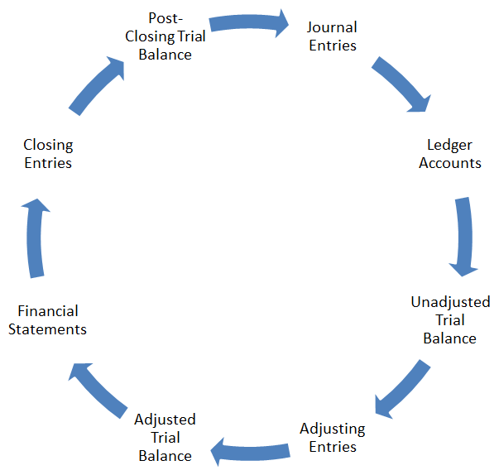

How Are Accounts Used to Keep Business Transactions Organized?
Accounts are the basic summary device of accounting; the detailed record of all the changes in a specific asset, liability, or stockholders’ equity item as a result of transactions
What Is Double-Entry Accounting?
        - Double-Entry is the rule of accounting that specifies every transaction must involve at least two accounts and is recorded with equal amounts of debits and credits.
        - Debit is the left side of any account; an entry made to the left side of an account.
        - Credit is the right side of any account; an entry made to the right side of an account.
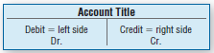
        - T-Account is an informal account form used to summarize transactions where the top of the T holds the account title and the base divides the debit and credit sides of the account. Exhibit 2-1 shows T-accounts along with which side increases/decreases.
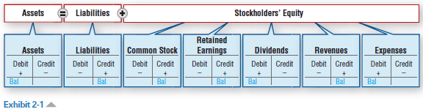
- Type of account determines whether it increases with a debit or a credit
- Asset accounts increase with a debit
- Expense accounts increase with a debit
- Liability accounts increase with a credit
- Revenue accounts increase with a credit
- Share capital (or common stock) increase with a credit
- The normal balance of an account is on the side of an increase to the account
Revenues and expenses affect equity
- Revenues are increases (earned) in equity from providing goods or services to customers
- Expenses are decreases (incurred) in equity through the operation of a business
    - Using up assets
    - Or increasing liabilities

How Are the General Journal and the General Ledger Used to Keep Track of Business Transactions?
A general journal is a chronological accounting record of the transactions of a business.
The general journal is a place to record events that have affected the business. Record means entering a transaction in a journal; also called journalize. A transaction is an event that has a financial impact on a business entity.
To record a journal entry:
      - Record the date
      - Record the debit part of the entry by entering the account title and then entering the amount in the debit column
      - Record the credit part of the entry on the next line by indenting the account title and then entering the amount in the credit column.
The general journal reflects transactions by date, so it does not provide useful information by individual accounts. To see the effect on accounts, these journal entries are posted to the general ledger.
A General Ledger is the accounting record that summarizes, in accounts, the transactions of a business and shows the resulting ending account balances.
Posting is copying information from the general journal to accounts in the general ledger.
      - Copy transaction date for the journal to the account in the ledger.
      - Copy the dollar amount of the debit from the journal as a debit into the account in the ledger.
Balance the T-Accounts
    - After the transactions are recorded and posted to the T-accounts, the balance in each account is calculated. The balance is the difference between an account’s total debit and total credit accounts; the ending value of an account.

How Is a Trial Balance Prepared and What Is It Used For?
  - A trial balance is a list of all the accounts of a business and their balances; its purpose is to verify that total debits equal total credits.
    - Not an official financial statement.
    - Format includes the heading (company name, statement name, date), and columns for the name of each account, the debit column, and the credit column. The debit and credit columns are total to ensure that debits equal credits.
    - Commonly prepared at the end of the accounting period but can be created any time.
      - The accounting period is the time period reflected by a set of financial statements.
        - Usually defined as a month, quarter or year.
  - Correcting Errors
    - The method to correct an error depends on the type of error made.
      - If a journal entry is made to the wrong accounts or for the wrong amount, reverse or undo the incorrect entry. Then create a new entry that records the correct information.
      - To correct an entry that has been made twice, one of the entries should be reversed.
      - If an entry was erroneously omitted, simply create and enter the journal entry.
  - Preparation of Financial Statements
    - Since the Trial Balance lists all of the accounts and their associated balances, it is often used to prepare financial statements.
    - Prepare the financial statements in the correct order
    - Make sure that the Balance Sheet is in balance. If not, check to see what you entered for the Retained Earnings account. Is it the beginning Retained Earnings account balance or the ending Retained Earnings balance which represents closing the income and expenses.

